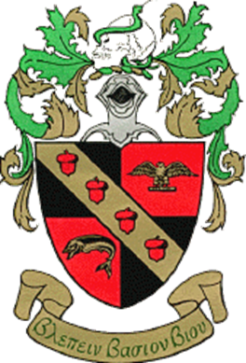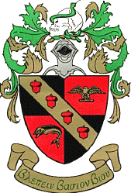**Tri Beta Biological National Honors Society**

**What is Tri Beta?**

**Tri Beta is a Biological National Honors Society that meets biweekly for academics and professional development within the Biological Sciences. Tri Beta’s objectives are to promote scholarship in the biological sciences, the dissemination of biological knowledge and encourage research.**

**Why Join Tri Beta Theta Lambda?**

**Tri Beta works towards academic development and making its members strong candidates for jobs and graduate school.**

**All members can apply for Local Awards while full members may apply for National Awards (see membership requirements below). Awards outlined upon expressed interest in joining.**

**What are Expectations of Tri Beta Members?**

**1) Regularly attend Biology Club meetings and events (at least 2 per year)**

**2) Regularly attend Tri Beta only meetings (At least 3 in one year with at least 1 a semester)**

**3) Participate in one community service event via Biology Club or Tri Beta per semester. Not included in the mandatory 2 meetings or events for Biology Club.**

**4) Contribute to the progress of the Chapter.**

**5) Know and understand the objectives of the society and its constitution.**

**Interested in Joining?**

**Come to our Recruitment: 3-4pm on 1/25, 2/8, 2/22, 3/15, 3/29, 4/12, 4/26 in the Bio Museum**

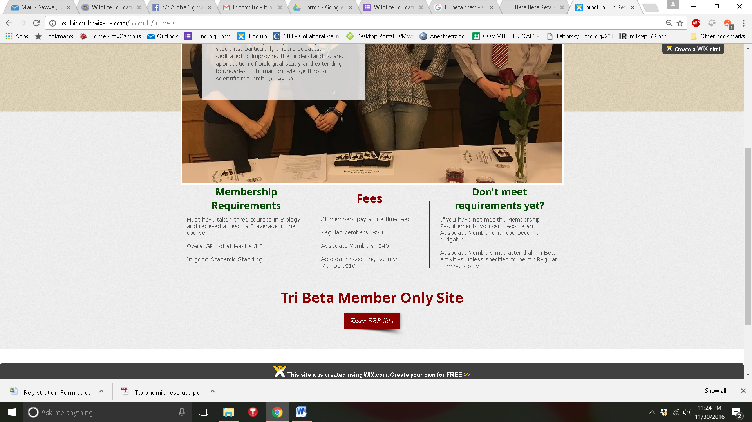***If you have any questions please email Biologyclub.Bridgewater@gmail.com***